

Tribhuvan University

Faculty of Humanities and Social Science

A PROJECT REPORT ON

**SECONDHAND VEHICLE STORE**

Submitted to

**Department of Computer Application**

**Model Campus Damak**

*In partial fulfillment of the requirements for the Bachelors in Computer Application*

Submitted by

Shristi Rijal

Reg. No: 3-2-1052-31-2021

Apekshya Dhakal

Reg. No: 6-2-504-4-2022

24th Falgun, 2081

Under the Supervision of

Mr. RK Singh



Tribhuvan University

Faculty of Humanities and Social Science

Model Campus Damak

Supervisor’s Recommendation

We hereby recommend that this project prepared under our supervision by “**Shristi Rijal & Apekshya Dhakal**” entitled “**SECONDHAND VEHICLE STORE**” in partial fulfillment of the requirements for the degree of Bachelor of Computer Application is recommended for the final evaluation.

SIGNATURE

Mr. RK Singh

SUPERVISOR

Humanities and Social Science

Model Campus Damak

Damak-05, Jhapa



Tribhuvan University

Faculty of Humanities and Social Science

Model Campus Damak

LETTER OF APPROVAL

This is to certify that this project prepared by “**Shristi Rijal & Apekshya Dhakal**” entitled “**SECONDHAND VEHICLE STORE**” in partial fulfillment of the requirements for the degree of Bachelor in Computer Application has been evaluated. In our opinion it is

satisfactory in the scope and quality as a project for the required degree.

|  |  |
| --- | --- |
| SIGNATURE of Supervisor  Mr. RK Singh  Humanities and Social Science | SIGNATURE of Coordinator  Mr. RK Singh  Humanities and Social Science |
| SIGNATURE of Internal  Examinar Internal Examinar | SIGNATURE of External  Examinar External Examinar |

**Abstract**

The “Secondhand Online Store” project aims to create an innovative and user-friendly platform that connects buyers and sellers of pre-owned vehicles. The primary objective is to streamline the process of buying and selling second-hand vehicles by leveraging modern web technologies, ensuring a seamless, transparent, and secure transaction experience for users.

The market for second-hand vehicles is substantial, with a growing number of consumers opting for used cars due to their affordability and value. However, the traditional methods of buying and selling these vehicles often involve significant challenges, including limited reach, lack of transparency, and potential fraud. This project addresses these issues by providing a centralized, digital platform that facilitates trustworthy transactions and offers a wide range of features to enhance user experience.

The aim of the project is to revolutionize the second-hand vehicle market by providing a comprehensive, secure, and user-friendly digital platform. By addressing the current challenges and enhancing the overall user experience, this project has the potential to significantly impact the way second-hand vehicles are bought and sold, fostering trust and convenience in the marketplace.

**Acknowledgement**

I express my sincere regard and indebtedness to my project external guide and Lecturer, Mr. RK Singh, Model Campus Damak, Jhapa for his valuable time, guidance, encouragement, support and cooperation throughout the duration of our project. I would sincerely like to thank BCA Department for giving me the opportunity to work on enhancing my technical skills while undergoing this project. This project helped in understanding the various parameters which are involved in the development of a web application and the working and integration of front end along with the back end to create

a fully functional web application.

I would like to thank Lecturer and Co-ordinator, Mr. RK Singh, BCA

Department and whole of department for their constant support.

Shristi Rijal

Apekshya Dhakal

Model Campus Damak

2022 Batch

**Table of Contents**

[Chapter 1 Introduction 1](#_bookmark1)

[1.1 Introduction 1](#_bookmark2)

[1.2 Problem Statement 1](#_bookmark3)

[1.3 Objectives 1](#_bookmark4)

[1.4 Scope and Limitations 1](#_bookmark5)

[1.5 Report Organization 2](#_bookmark6)

[Chapter 2 Background Study and Literature Review 4](#_bookmark7)

[2.1 Background Study 4](#_bookmark8)

[2.2 Literature Review 4](#_bookmark9)

[Chapter 3 System Analysis and Design 6](#_bookmark10)

[3.1 System Analysis 6](#_bookmark11)

[3.1.1. Requirement Analysis 6](#_bookmark12)

[3.1.2. Feasibility Study 7](#_bookmark13)

[3.1.3. Data Modeling (Entity Relationship Diagram) 8](#_bookmark14)

[3.1.4. Process Modeling (DFD) 9](#_bookmark15)

[3.2. System Design 10](#_bookmark16)

[3.2.1. Architectural Design 11](#_bookmark17)

[3.2.2. Data Schema Design 12](#_bookmark18)

[Chapter 4: Implementation& Testing 14](#_bookmark19)

[4.1. Implementation 14](#_bookmark20)

[4.1.1. Tools Used (CASE tools, Programming languages, Database platforms) 14](#_bookmark21)

[1. Database Design: 14](#_bookmark22)

[2. Backend Development (PHP): 14](#_bookmark23)

[3. Frontend Development (HTML, CSS, JavaScript): 14](#_bookmark24)

[4. Integration (PHP and JavaScript): 15](#_bookmark25)

[5. Security Measures: 15](#_bookmark26)

[4.1.2. Implementation Details of Modules (Description of procedures/functions) 15](#_bookmark27)

[Admin Module 17](#_bookmark28)

[4.2. Testing 17](#_bookmark29)

[4.2.1. Test Cases for Unit Testing 17](#_bookmark30)

[4.2.2. Test Cases for System Testing 20](#_bookmark31)

[Chapter 5: Conclusion and Future Recommendations 22](#_bookmark32)

[5.1 Lesson Learnt: 22](#_bookmark33)

[5.2 Conclusion 23](#_bookmark34)

[5.3 Future Recommendations 23](#_bookmark35)

[Appendices 24](#_bookmark36)

Referenes…………………………………………………………………………………29

**List of Figures**

[1: Figure 1: Use Case Diagram 6](#_bookmark37)

[2: Figure 2: - Gantt Chart 8](#_bookmark38)

[3: Figure 3: - Entity Relationship Diagram 9](#_bookmark39)

[4: Figure 4: - DFD Level 0 9](#_bookmark40)

[5: Figure 5: - DFD Level 1 10](#_bookmark41)

[6: Figure 6: - Waterfall Model 11](#_bookmark42)

[7: Figure 7: - Architecture Design 12](#_bookmark43)

[8: Figure 8: - Design of Schema 12](#_bookmark44)

9:[Figure 9: - System Function Module 15](#_bookmark45)

10.Figure:10: -Login Page……………………………………………………………….24

11.Figure11:-Home Page…………………………………………………………………24

12.Figure12:-Home Page…………………………………………………………………25

13.Figure13:-Shop Page………………………………………………………………….25

14.Figure14:-About Page………………………………………………………………...26

15.Figure15:-Admin Page………………………………………………………………..26

16.Figure16:-AddProduct Page…………………………………………………………..27

17.Figure17:-Book Request Page……………………………………………………..…27

18.Figure18:-Book Info Page……………………………………………………………28

**List of Abbreviations**

BCA : Bachelor in Computer Application

CASE : Computer Aided Software Engineering

HTML : Hypertext Markup Language

CSS : Cascading Style Sheets

CRUD : Create, Read, Update and Delete

Fig : Figure

MySQL : My Structured Query Language

PHP : Hypertext Preprocessor

**List of Tables**

[Table 1 : Test Case For Login: 18](#_bookmark46)

[Table 2: Test Case For Sign Up: 19](#_bookmark47)

[Table 3: Test Case: Login, Register/Sign Up and Logout: 20](#_bookmark48)

**Chapter 1 Introduction**

**1.1 Introduction**

Purano Pasal can be an exciting venture given the ongoing demand for quality pre-owned cars, motorcycles, scooter and other vehicles.

The main goal of secondhand vehicle store provide with vehicle histories and information about each vehicle’s condition, maintenance, and any available warranties.

Our dealership offers a welcoming environment where you can browse our inventory, take test drive and make an informed decision and confidence. Additionally, we have convenient financing options like offering customer with loan system as well as on the system of installment to help you drive away in your ideal vehicles without unnecessary stress.

**1.2 Problem Statement**

In context of Nepal, many customers have to face hurdles while buying second hand vehicles. This system is only available to recommended places. As Nepali person, they want very cheap price to buy valuable vehicles which is not possible. An interested customer often gets ignored while surfing website. To address these issues, the "Secondhand Vehicle Store" project aims to develop a comprehensive, secure, and user- friendly platform. This project seeks to transform the used vehicle market into a more efficient, trustworthy, and convenient space for all users.

**1.3 Objectives**

* To provide comprehensive information about pre-owned vehicles, including their condition, maintenance history, warranties, and personalized recommendations based on customers' financial capacity, needs, and preferences.
* To assist customers with financial advice and support, facilitating informed decisions and smooth vehicle purchase processes.

**1.4 Scope and Limitations**

**Scope**

* Easy to use
* Any (authorized, guest) user can use this system.
* User registration and authentication.
* Listings of vehicles with detailed information.
* Admin panel for managing listings and users.
* Secure transactions and communication

**Limitation**

* This system is only available while connected to the internet.
* Many competitors make it challenging to stand out among competitors.
* Building trust in an online environment is challenging.
* No email alert, they have to login to the system.
* This system is only available to recommended places.

**1.5 Report Organization**

**Chapter 1**

The first part of the report contains the summarized introduction of the whole report. It includes the overview, scope and limitation, problem statement and objectives of

this project.

**Chapter 2**

The second chapter include background study i.e. description of fundamental theories, general concepts and terminology related to the project. It also includes the literature review

i.e. review of the similar projects, research and theories done by other researchers.

**Chapter 3**

The third chapter includes the system analysis and design phase in which the report of functional and non-functional requirements of the project is stated using use case and system diagrams. It also includes the feasibility study about the system which explains whether the system development process is affordable and within the knowledge range of the developers. It shows the technical, operational and economic feasibility of the project development phase. The explanation of the designing of the system is also done in this chapter. It includes data modelling and process modelling which is explained byusing ER diagram and Data Flow Diagram. The architectural design, database design and the user

interface design is also listed in this chapter.

**Chapter 4**

The fourth chapter includes the implementation and testing phase of the proposed system. In the implementation phase, the tools like CASE tools, programming languages and

database platforms are implemented.

**Chapter 5**

The fifth chapter includes conclusion and future recommendation. This contains the final paragraphs of the report and in this phase the overall outcome and the developer’spoint of view is written. The lesson that I learned through all the phases can also be included in this

phase.

**Chapter 2 Background Study and Literature Review**

**2.1 Background Study**

The Purano Pasal project encompasses a comprehensive background study essential for its development and functionality. At its core, the platform consists of an admin panel and a user interface, each serving distinct roles in managing and accessing the website's content. The admin panel acts as the backend interface, empowering administrators with privileges to oversee product management tasks. This includes adding new vehicle listings, updating existing information, and removing outdated products. Meanwhile, the user interface serves as the frontend gateway for users, offering them a seamless experience to browse through the listed vehicles. To access the website, users are required to authenticate themselves through a registration process, providing necessary credentials such as usernames and passwords. The concept of product management is fundamental, encompassing the crucial tasks of adding, updating, and deleting products, ensuring the website's inventory remains accurate and up to date. Essential terminologies include second-hand vehicles, admin panel, user interface, authentication, and registration. These concepts form the backbone of the project, facilitating the development of an intuitive, secure, and efficient online

marketplace for second-hand vehicles.

**2.2 Literature Review**

In the realm of online marketplaces specializing in second-hand vehicles, a plethora of studies and research papers have explored various facts of consumer behaviour, market dynamics, and technological advancements. One critical area of inquiry revolves around

consumer trust and confidence in purchasing pre-owned vehicles online.

For this researched, [1] we researched and review several kind of related website and applications as well as some store also. Throughout the research, we get to find out there

are few useful website related to online store for pre-owned vehicles.

In the context of Nepal, [2] many potential customers are not satisfied with the websites and its services because these kind of services in only available in metro city. If some websites are available for users, we found the websites are looking many features regarding the services. Websites such as HamroBazar [3], NADA (Nepal Automobile Dealers Association) [4], and various Facebook groups have emerged as popular platforms for

listing and purchasing used vehicles. Design and functionality of online platforms are

crucial for user satisfaction in Nepal. According to Thapa (2018), many local platforms lack user-friendly interfaces and advanced search functionalities, making it difficult for users to

find suitable vehicles.

Other websites such as NepBay [5], HamroMotors[6], Meroauto[7], and GariKhabar[8] have become prominent in this space. However, these platforms face several challenges, including trust and transparency issues, security concerns, poor user interfaces, and a lack of integrated services. Studies highlight the need for robust vehicle verification processes, secure online payment gateways, user reviews, ratings, and collaboration with certified inspection services to build user trust. Furthermore, user-friendly designs with advanced search functionalities and mobile optimization are crucial for enhancing user experience. Integrating additional services such as vehicle inspections, financing, and warranties can add significant value, differentiating these platforms from competitors. Addressing these challenges through innovative solutions will ensure a seamless and trustworthy experience for all users in the online used vehicle market in Nepal. Future efforts should focus on developing comprehensive, secure, and user-friendly platforms to cater to the growing

market demands.

**Chapter 3 System Analysis and Design**

**3.1 System Analysis**

System analysis is a critical phase in the development of any software project, including the creation of an online second hand vehicle store like Purano Pasal. This phase involves a detailed examination of user requirements, system functionalities and technical specification to ensure that the resulting system meets the needs of its stakeholders effectively and efficiently.

**3.1.1. Requirement Analysis**

There are two types of requirements.

**i. Functional Requirements** (Illustrated using use case diagram/list)

|  |
| --- |
| functionalreq_cleanup |

*1: Figure 1: Use Case Diagram*

**1. User:**

* Users can browse the product and book the product details.
* Users can login to the system.
* Users can register

**2. Admin**

* Admin will be able to check the user’s information
* Admin can login to the administrator system.
* Admin can list and edit listing in the system.

**ii. Non-functional requirements**

. **Availability:** It will be available online. It will be available for access at 24 hours,

7 days a week. Also, in the occurrence of any major Malfunctioning, the system will be Available in 1 to 2 working days, so that business process is not severely affected.

. **Security:** This system will be secure, and the user’s information won’t be available for others for users ’privacy. The system provides username and password to prevent the system from unauthorized access.

. **Performance:** This system will be designed for smooth performance with

optimization and good response. The system will have high performance rate

when executing user’s input and will be able to provide response within short time span usually 50 seconds for highly complicated task and 20 to 25 seconds for less complicated task.

. **Reliability:** It will be reliable for the users.

**3.1.2. Feasibility Study**

**a) Operational feasibility:**

* The user must have internet browser in their computer.
* The procedure is then clicking the icon and go the homepage.
* Without any technical background, user can use this application. So, this project is operationally feasible.

**b) Economic feasibility:**

The project is economically feasible because the user can enter system through laptops so there is no cost on the resources needed for the development of the system and additional internet services.

**c) Technical feasibility:**

* **Easy to use:** The user is assumed to be students having knowledge of simple computer operation.
* **Serviceability:** This project will try to provide maximum possible services to the user where user can choose their own bike in their own time.
* **Portability:** It can be transferred from one server to another using secondary storage devices.
* **Maintainability:** This project was built keeping in mind all the necessary functions so no essential update is required.
* **Reliability:** Detail study for information gathering was done from reliable sources. So, the user can be sure of the services provided by this program.

**d) Schedule**

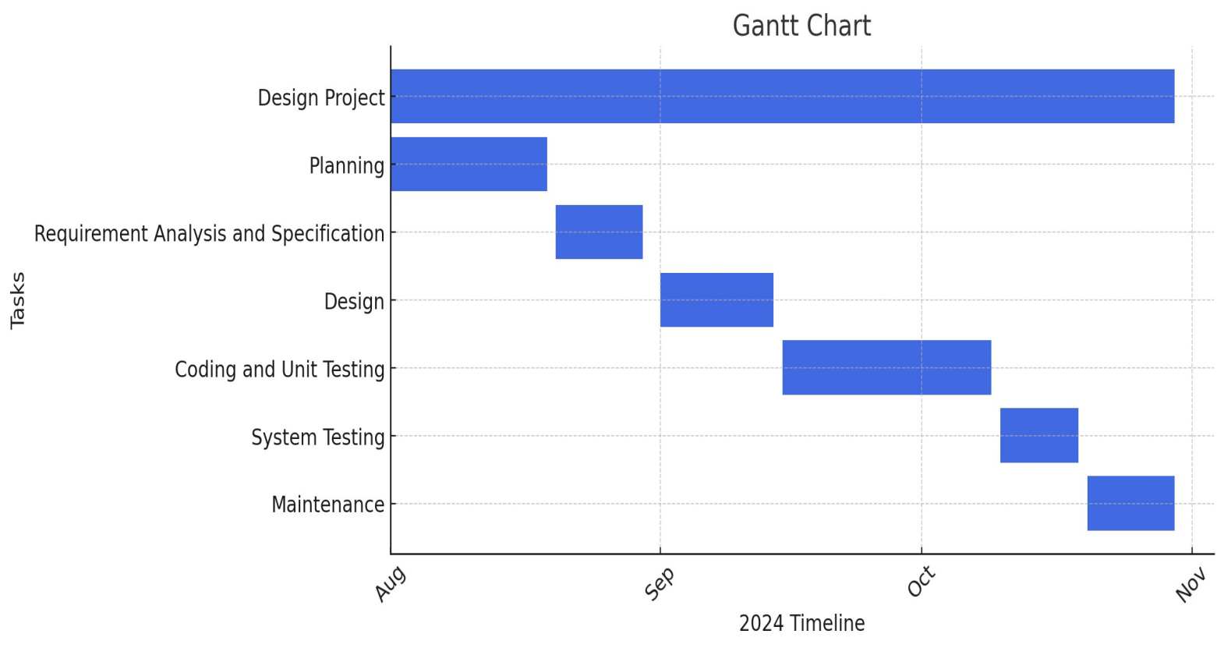

*2: Figure 2: - Gantt Chart*

**3.1.3. Data Modeling (Entity Relationship Diagram)**

The entity relationship diagram describes the relationship between entities, cardinality and their attributes. Entity–relationship model (ER model) is a data model for describing the data or information aspects of a business domain or its process requirements, in an abstract way that lends itself to ultimately being implemented in a database such as a relational database. The main components of ER models are entities (things) and the relationships that can exist among them. In here we provide a description of entities with all their attributes. Describing entity name, business definition for the entities and their attribute and

domain.



|  |
| --- |
| C:\Users\SHRISTI RIJAL\OneDrive\Documents\final_enhanced_er_diagram.pngfinal_enhanced_er_diagram |

1

M

N 1

M M

M M

M

M

M M

*3: Figure 3: - Entity Relationship Diagram*

**3.1.4. Process Modeling (DFD)**

Data flow diagram (DFD) is used to define the flow of the system and its resources such as information. Data flow diagram is away of expressing system requirements in a graphical manner. DFD represents one of the most ingenious tools used for structured analysis. A DFD is also known as bubble chat. It has the purpose of clarifying system requirements and identifying major transformations that will become programs in system design.

Login Credentials

Response

|  |
| --- |
| User |

|  |
| --- |
| Admin |



System

Login Request

Response

*4: Figure 4: - DFD Level 0*

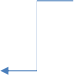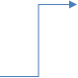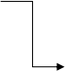

Verify User

Register

|  |  |
| --- | --- |
| D | Product |

Update

Product Information

Update Users

User

Information

Insert / Update / Delete product

|  |
| --- |
| D Users |

View Users

Request

Sold

product Information

|  |
| --- |
| D Sold\_product |

 Buy

View product details

|  |
| --- |
| User |

Book Product request

Add user Details

Product

User

Management

Product

Management

|  |
| --- |
| Admin |

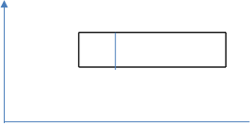

View

Booked Product

D Booked product

Sold Product Info

View Product Details

*5: Figure 5: - DFD Level 1*

**3.2. System Design**

System design is the process of defining the components, modules, interfaces, and data for a system to satisfy specified requirements. System development is the process of creating or altering systems, along with the processes, practices, models, and methodologies used to develop them. This project has specific documentation, ample time, fixed requirements, well- understood technology so in order to build this system, water fall methodology is used.

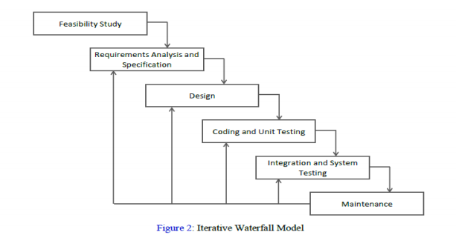

|  |
| --- |
| Planning |

*6: Figure 6: - Waterfall Model*

The Waterfall Model was the first Process Model to be introduced. It is also referred to as linear-sequential lifecycle model. It is very simple to understand and use. In a waterfall model, each phase must be completed before the next phase can be begin and there is no overlapping in the phases. It is easy to arrange tasks and clearly defined stages.

**3.2.1. Architectural Design**

Architectural Design is a concept that focuses on components or elements of a structure. An architect is generally the one in charge of the architectural design. They work with space

and elements to create a coherent and functional structure.

Below is the architectural (flowchart) of the system. It describeshow out system will work. First of all, the user has to register into the system. Now, the user can search bus, reserved bus and book the bus. As the admin can add the brand of bus, delete the bus, and replace

the bus.

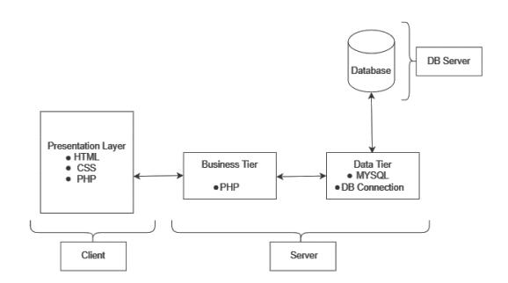

|  |  |
| --- | --- |
| |  | | --- | | JavaScripta | |

*7: Figure 7: - Architecture Design*

**3.2.2. Data Schema Design**

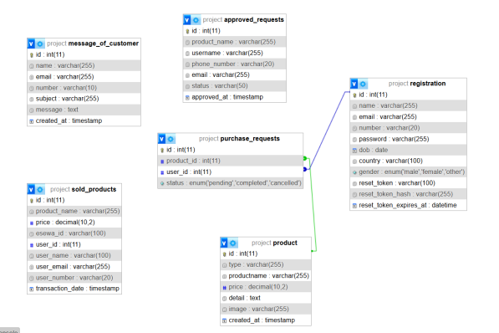

*8: Figure 8: - Design of Schema*

The above figure is about the tables created in database. A database schema represents the logical configuration of all or part of a relational database. It can exist both as a visual representation and as a set of formulas known as integrity constraints that govern a

database. These formulas are expressed in a data definition language, such as SQL.

**Chapter 4: Implementation& Testing**

**4.1. Implementation**

During this phase, the theoretical design is translated into a practical, working system. It marks a crucial stage in the development process, as it aims to create a system that operates efficiently and effectively. Implementation occurs after thorough testing has been conducted and the system has been verified to meet the specified requirements.

**4.1.1. Tools Used (CASE tools, Programming languages, Database platforms)**

Tools that are used while designing this website are:

Front end: HTML, CSS, JavaScript

Back end: PHP, MySQL

**1. Database Design:**

**MySQL Database**: Set up a MySQL database to store information about vehicles and users.

**Tables**: Create tables such as vehicles and users with appropriate fields.

**Relationship**s: Establish relationships between tables.

**2. Backend Development (PHP):**

**Server-Side Logic:**

Developed PHP scripts to handle backend logic, including CRUD operations for managing vehicles and user authentication.

**User Authentication:**

Implemented user authentication mechanisms using PHP sessions and secure password hashing.

**Admin Panel Functionality:**

Created PHP scripts for the admin panel to add, update, and delete vehicle listings.

**3. Frontend Development (HTML, CSS, JavaScript):**

**User Interface Design:**

Designed user-friendly interfaces using HTML for structure, CSS for styling, and JavaScript for interactivity.

**Registration/Login Page:**

Created registration and login pages for users to access the website.

**Admin Panel Interface:**

|  |
| --- |
| Admin  Module |

|  |
| --- |
| Vehicle manageme nt Module |

Designed a separate interface for the admin panel with intuitive controls for managing products.

**4. Integration (PHP and JavaScript):**

**Server-Client Communication:**

Integrated PHP scripts with frontend pages to fetch and display data dynamically.

**Form Handling:**

Implemented JavaScript form validation and submission handlers for user input.

**5. Security Measures:**

**Password Security:**

Hashed user passwords using hashing algorithms before storing them in the database.

**Session Management:**

Used PHP sessions securely to manage user authentication and authorization.

**4.1.2. Implementation Details of Modules (Description of procedures/functions)**

The System Function Module encompasses core functionalities required for the smooth operation of the online second-hand vehicles store. It includes procedures and functions related to user authentication, vehicle management, and administrative tasks.

|  |
| --- |
| Second-hand vehicles store |



|  |
| --- |
| User  Module |

*Figure 9: - System Function Module*

**User Module:**

**Register User** (username, email, and password):

Registers a new user by storing their username, email, and hashed password securely in the database.

**Login User** (username/email, password):

Authenticates users by verifying their credentials against stored data, allowing access upon successful validation.

**Logout User ():**

Logs out currently logged-in users, destroying their session and redirecting them to the homepage.

**Validate Input (input)**: Validates user input during registration and login to prevent SQL injection and other security vulnerabilities.

**Vehicle Management Module:**

**GetVehicleList ()**: Retrieves a list of available vehicles from the database, displaying them on the website's shop page.

**Add Vehicle(make, model, year, mileage, and price)**: Allows administrators to add new vehicle listings by providing relevant details such as make, model, year, mileage, and price.

**Update Vehicle (updated Info):** Enables administrators to update existing vehicle listings with revised information, ensuring data accuracy and relevance.

**Delete Vehicle (vehicle ID):** Permits administrators to remove vehicle listings from the database, maintaining an up-to-date inventory.

**Booked Vehicle (vehicle book):** User can book product according to their need.

**Admin Panel Management:**

**AdminLogin(username, password):**

Validates administrator credentials to grant access to the admin panel, ensuring secure management of website content.

**AdminDashboard:**

Displays an overview of key metrics and options for managing vehicle listings and user accounts within the admin panel.

**AddProduct Form:**

Renders a form for administrators to add new vehicle listings, collecting necessary information for database insertion.

**UpdateProductForm(vehicleID):**

Renders a pre-filled form for administrators to edit existing vehicle listings, streamlining the update process.

**DeleteProductConfirmation(vehicle ID):**

Displays a confirmation message and prompts administrators to confirm their intention to delete a vehicle listing.

**Admin Module**

The admin module controls the administration of the system. The admin can check each product details and can remove if needed. Admin can add a product, manage booking product, and book and enquiry.

**Manage vehicle:** Admin can create new vehicle, edit vehicles and delete vehicle details.

**Manage booking:**  Admin can manage and view booking. Admin decides whether to confirm and cancel the booking of customer. And cancel already confirmed booking on getting a cancelation request from the user.

**View query:** Admin a can view queries of the customer and do the needful.

**View registered users:** Admin can view the no. of registered users and their details.

**4.2. Testing**

Testing is a crucial phase in software development to ensure the quality, reliability, and functionality of the system. It involves validating the system against specified requirements and identifying and rectifying any defects or discrepancies. Testing encompasses various techniques and methodologies to assess different aspects of the system, including functionality, usability, performance, security, and compatibility.

**4.2.1. Test Cases for Unit Testing**

Unit testing is a testing technique that focuses on validating individual units or components of the system in isolation. Each unit, such as a function or method, is tested independently to verify its correctness and functionality. Unit tests typically involve providing input values and comparing the expected output with the actual output to detect any discrepancies or errors.

We have tested each view/module of the application individually. As the modules were built up testing was carried out simultaneously, tracking out each and every kind of input and checking the corresponding output until module is working correctly.

**Test case 1: Product Listings:**

**Description:** Verify that all listed products are displayed correctly on the user interface

**Steps:** Enter admin panel, check product information.

**Expected Result:** Product should be listed and should be displayed correctly.

**Test Success/Fail:** Success

**Test case 2: Security Testing:**

**Description:** Verify that sensitive user data, such as passwords, are securely hashed before storage.

**Steps:** Goto database, open register information.

**Expected Result:** Password needs to be hashed and stored in database.

**Test Success/Fail:** Success

*Table 1 :* ***Test Case For Login:***

|  |  |  |  |  |  |
| --- | --- | --- | --- | --- | --- |
| S.N | Data Input | Excepted Output | | Actual Output | Pass/Fail |
| 1. | All files are  empty. | Error message:  indicates compulsory  fields | | Error message:  Indicates compulsory  fields | Pass |
| 2. | Email | Error  Invalid  address. | message:  Email- | Error message:  Invalid  email-address | Pass |
| 3. | Password and  confirm  Password | Error message: Both Password doesn’t  match. | | Error message: Both Password doesn’t  match. | Pass |
| 4. | Login | Login into the system should be try with the login assigned by the admin and correct  password. | | Login should be successful and the user should enter into  the system. | Fail |
| The System give an error and denied fromthe login. | | Login should fail with an error .Invalid details. | Pass |
| 5. | User | Login should be allow and admin get  adminhomepage. | | Login successfully and admin get its  adminhomepage. | Pass |

*Table 2:* ***Test Case For Sign Up:***

|  |  |  |  |  |  |  |
| --- | --- | --- | --- | --- | --- | --- |
| **S.N** | **Data Input** | **Expected Result** | | **Actual Output** | | **Pass/Fail** |
| 1 | Register with valid and unique username,email, and matching password | Redirect to login page with success message | | Redirect to login page with success message | | Pass |
| 2 | Attempt to register with an already existing email | Display error message "Email already exists" | | Display error message "Email already exists" | | Pass |
| 3 | Attempt to register with  mismatched password  confirmation | Display error  message  "Passwords do not match" | | Display error  message  "Passwords do not match" | | Pass |
| 4 | Register without providing  username | Display  message  "Username required" | error  is | Display  message  "Username required" | error  is | Pass |
| 5 | Register with invalid email format | Display error message "Invalid email address" | | Display error message "Invalid email address" | | Pass |
| 6 | Register with a password shorter than the required length | Display error  message  "Password is too short" | | Display error  message  "Password is too short" | | Pass |
| 7 | Register with empty password field | Display  message  "Password required" | error  is | Display  message  "Password required" | error  is | Pass |
| 8 | Register with valid username and email but leave confirm password empty | Display error message "Confirm password is required" | | Display error message "Confirm password is required" | | Pass |

*Table 3:* ***Test Case: Login, Register/Sign Up and Logout:***

|  |  |  |  |
| --- | --- | --- | --- |
| Step | Procedures | Expected result | Result |
| 1 | Insert admin, username and  password | Save the insert data into database | Success |
| 2 | Insert correct username, password for login | Verify the admin | Success |
| 3 | Click ‘Register’, ‘Login’, button | Application redirect  admin to Login page after register and Main page after login | Success |
| 4 | Repeat step 2 and 3 for login using false username, password | Application display  error message | Success |
| 5 | Update admin account | New update data saved into database | Success |
| 6 | Logout Account | Log out redirected to login page | Success |
| Precondition | | No credentials are currently login | |
| Post-condition | | New and updated admin name, username, and password saved in database | |

**4.2.2. Test Cases for System Testing**

System testing is a crucial phase in the development lifecycle where the entire system is tested to ensure that all components work together as expected and meet the specified requirements. In the context of our online second-hand vehicles store website, the following test cases is formulated to verify the functionality and reliability of the system.

**User Authentication:**

**Test Case 1:** Verify that users can successfully register for an account using the registration page.

**Steps:**  Enter valid registration details (username, email, password and other required information), submit registration form

**Expected Result:** New user should be registered and added to the database.

**Test Success/Fail:** Success

**Test Case 2:** Validate that registered users can log in with correct credentials and access the website.

**Steps:** Enter valid Username and password, submit sign in form

**Expected Result:** Users should be logged in into the website.

**Test Success/Fail:** Success

**Admin Panel Functionality:**

**Test Case 1:** Test the ability of admins to update existing product details accurately.

**Steps:** open admin panel, go to product details, and click on edit button and update the product details

**Expected Result:** Product details should be updated

**Test Success/Fail:** Success

**Test Case 2**: Validate that changes made in the admin panel reflect instantly on the user interface.

**Steps:** login admin dashboard, make changes in the product (insert/delete/modify)

**Expected Result:** After submitted the changes which is made in product should instantly reflect on user interface.

**Test Success/Fail:** Success

**Chapter 5: Conclusion and Future Recommendations**

**5.1 Lesson Learnt:**

Throughout the development and implementation of our online second-hand vehicles store, several key lessons have been learned that are valuable for future projects and iterations. These lessons encompass various aspects of both technical and non-technical considerations:

**Effective Communication is Essential:**

Clear and concise communication between team members and users is crucial for the success of the project. Regular updates, feedback sessions, and documentation reviews help in aligning expectations and addressing concerns promptly.

**Continuous Testing and Quality Assurance:**

Rigorous testing and quality assurance procedures are indispensable for identifying and resolving issues early in the development process. From functionality and performance testing to security audits and user acceptance testing, thorough testing ensures that the website meets quality standards and delivers a seamless experience to users.

**Adaptability and Flexibility:**

The digital landscape is constantly evolving, and the ability to adapt to changing technologies, market trends, and user preferences is crucial for staying competitive. Future iterations of the website should incorporate mechanisms for scalability, flexibility, and extensibility to accommodate future enhancements and expansions seamlessly.

**Security is Non-Negotiable:**

Protecting user data and ensuring the security of the website are non-negotiable aspects of any online platform.

**Collaboration and Teamwork:**

Effective collaboration and teamwork are fundamental to the success of the project. Leveraging each team member's expertise and fostering a collaborative environment enables efficient problem-solving, innovation, and creativity. Moving forward, encouraging open communication, mutual respect, and shared accountability will continue to drive the project's success.

In conclusion, the development of our online second-hand vehicles store (Purano Pasal) has been a valuable learning experience, highlighting the importance of user experience, communication, testing, adaptability, security, and collaboration. By incorporating these lessons into future iterations and endeavors, we can continue to deliver exceptional value to our users and stakeholders while striving for continuous improvement and innovation.

**5.2 Conclusion**

The "Purano Pasal" project is a user-friendly and flexible e-commerce platform for second-hand vehicles, developed using HTML, CSS, JavaScript, PHP, and MySQL. It successfully fulfills most requirements, with minor pending tasks that can be addressed quickly. The website features an intuitive user interface that allows users to browse vehicles, view details, and make informed purchases, with JavaScript enhancing interactivity and engagement. The admin panel enables efficient management of content, allowing real-time updates for product listings. Robust user authentication ensures data security and prevents unauthorized access. The platform demonstrates effective integration of frontend and backend technologies, offering a functional and efficient system. Future updates will focus on feature enhancements, performance optimization, and adapting to user and market needs.

**5.3 Future Recommendations**

While the current implementation of the online second-hand vehicles store (Purano Pasal) provides a solid foundation for users and administrators alike, there are several areas for potential enhancement and future development. Below are some recommendations for further improving the website:

1. Enhanced Search and Filtering Options:

2. Mobile Application

3. Social Media Integration:

4. Expansion of Payment Options:

**Appendices**

**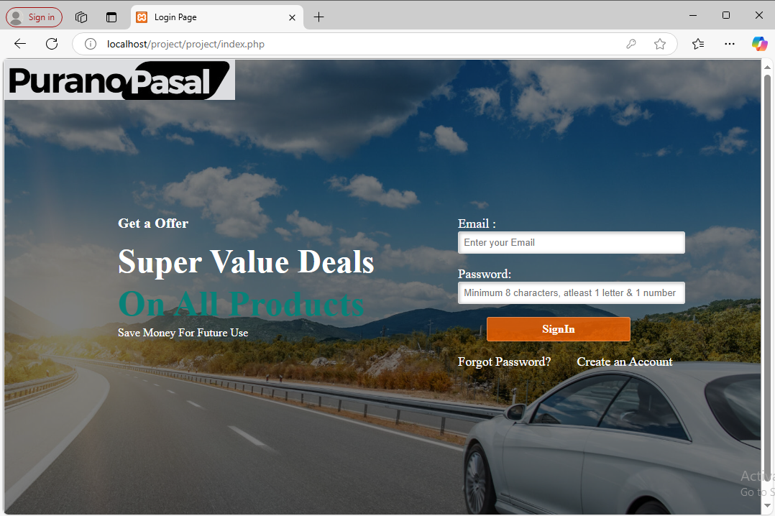**

Figure10: User Login Page

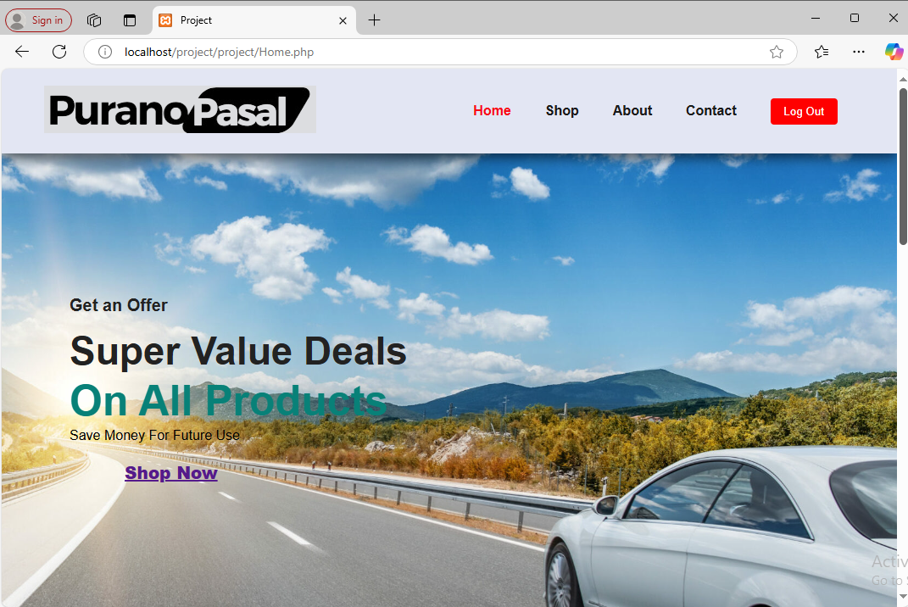

Figure11: Home Page

.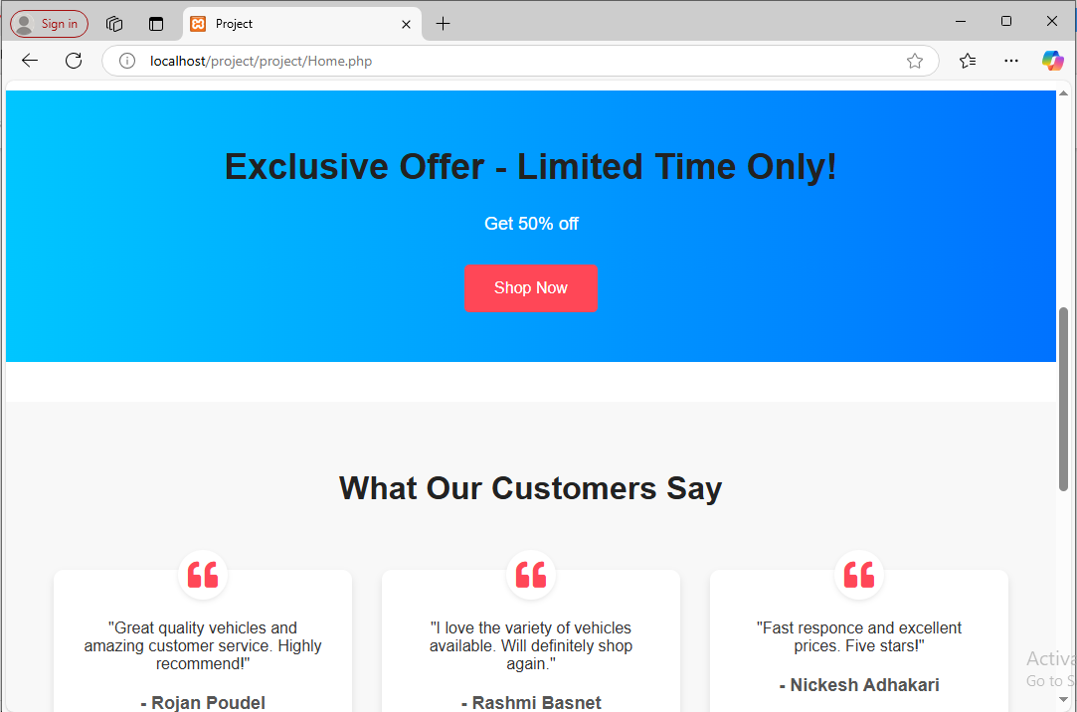

Figure12: Home Page

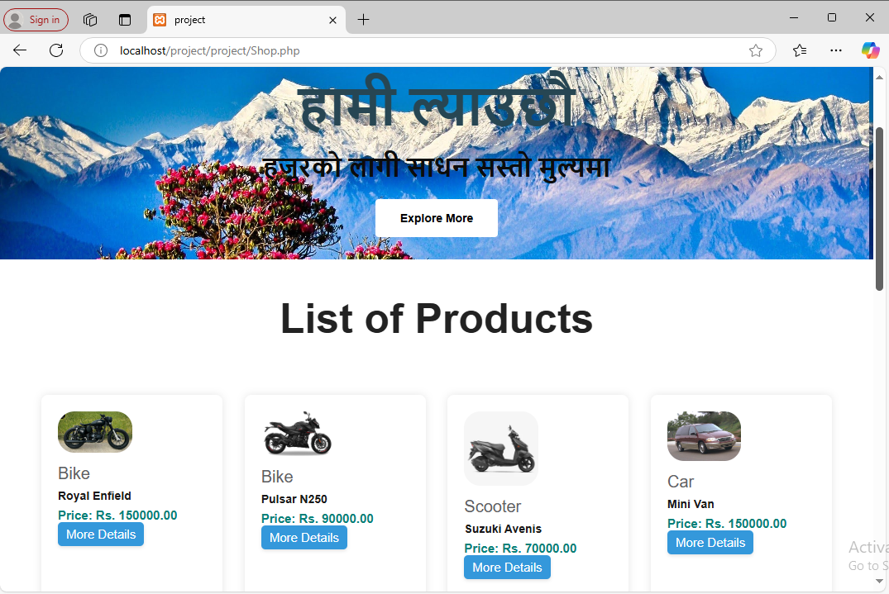

Figure13: Shop Page

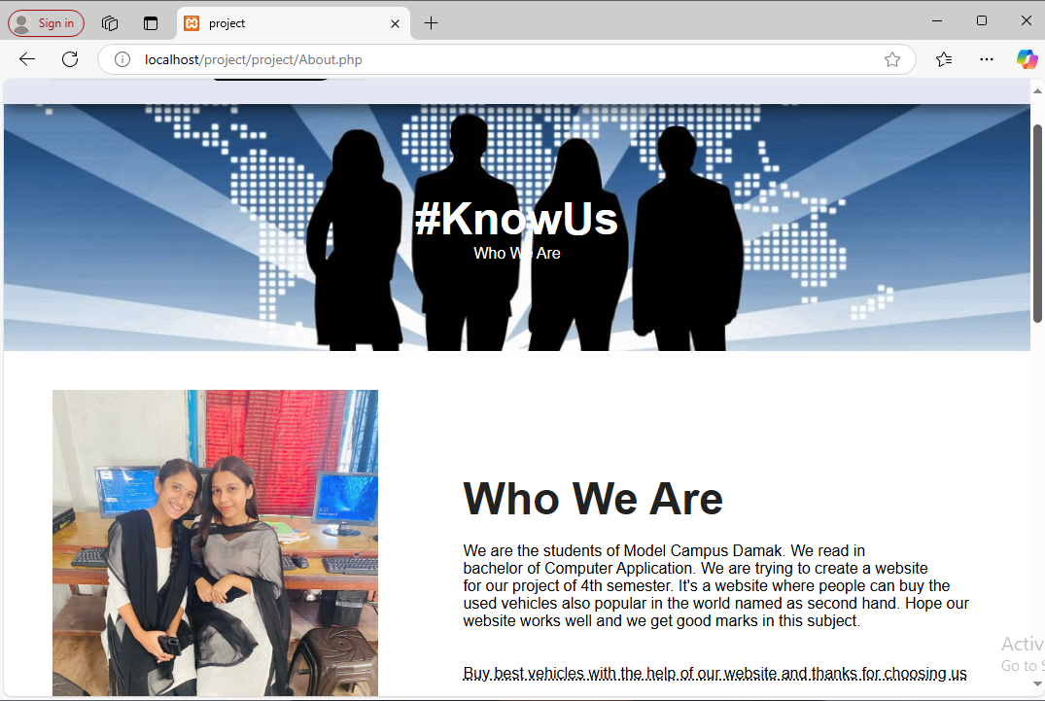

Figure14: About Page

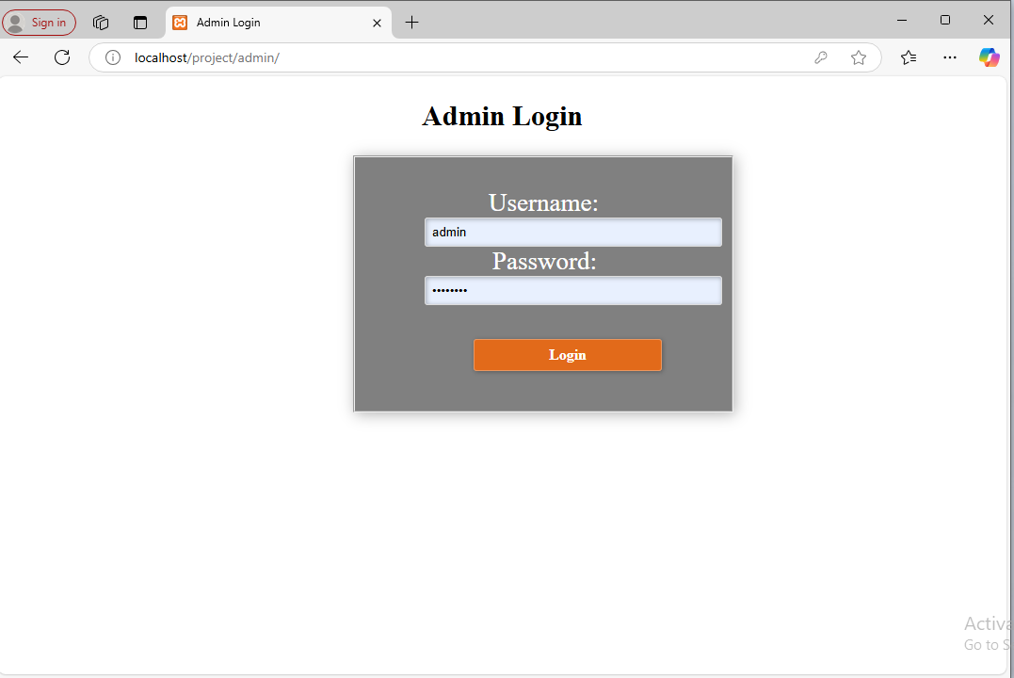

Figure15: Admin Page

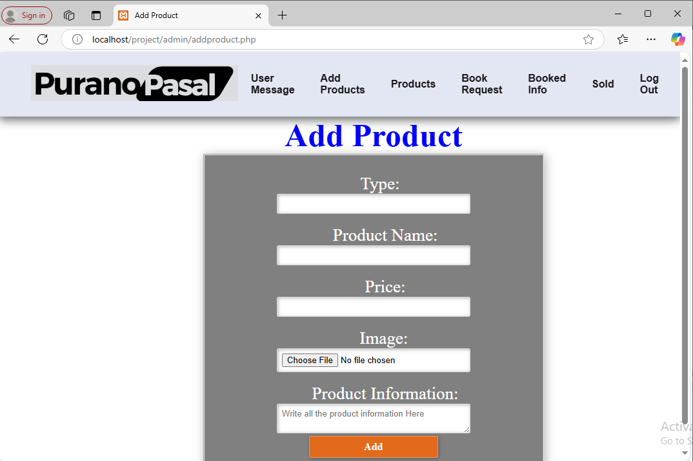

Figure16: Add Product Page

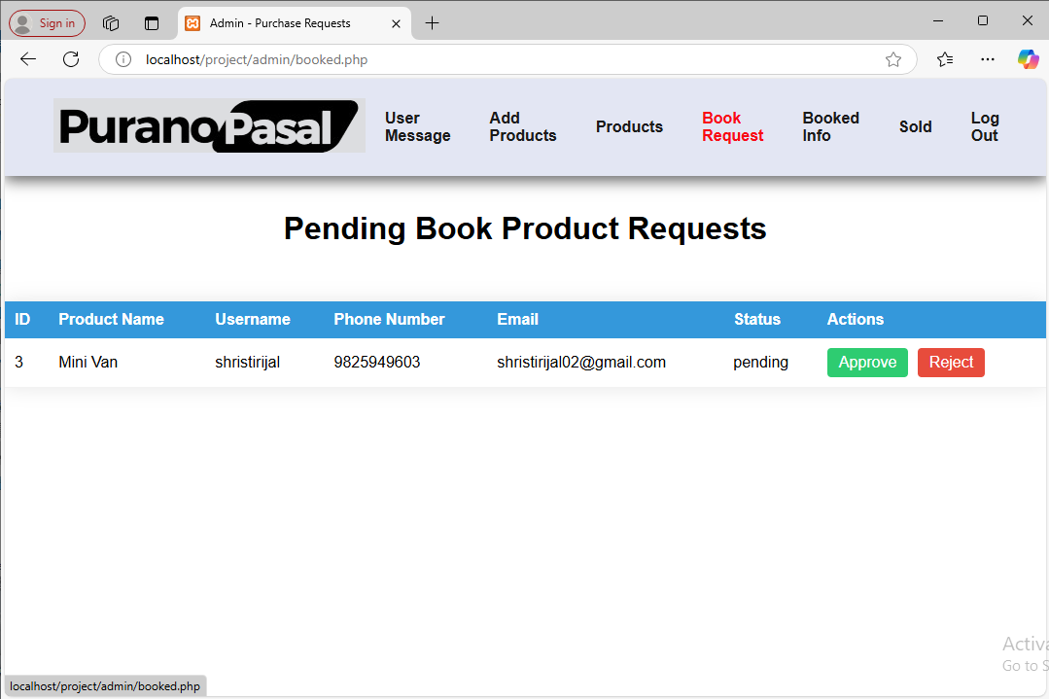

Figure17: Book Request Page

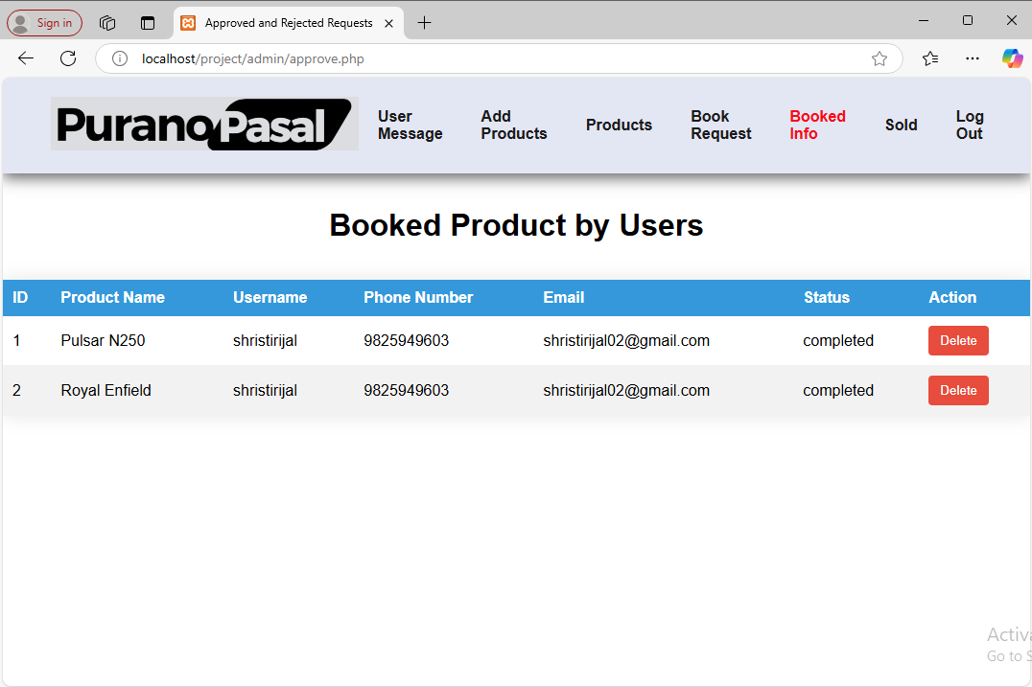

Figure18: Book Info Page

**References**

Books:

[1] Sharma, R. (2021). *Digital Platforms in the Nepalese Automotive Market: An Overview.* Kathmandu Publishing House.

[2] **Joshi, P. (2019).** *E-Commerce Trends in Nepal’s Used Vehicle Market.* Himalayan Books.

Website:

[3] HamroBazar. (n.d.). *Used Cars for Sale.* Retrieved July 25, 2024, from <https://www.hamrobazar.com/vehicles/used>-cars

[4] NADA (Nepal Automobile Dealers Association). (n.d**.).** *Find Authorized Dealers and*

*Used Cars.* Retrieved July 25, 2024, from<https://www.nadaauto.com/> [5] NepBay <https://nepbay.com.atlaq.com/>

[6] Hamroautomobile: “We have everything you need”, [Online] .

Available: <https://hamroautomobile.com/>

[7] Meroauto. “Meroauto – Accelerate with us,” [Online].

Available: <https://www.meroauto.com/>